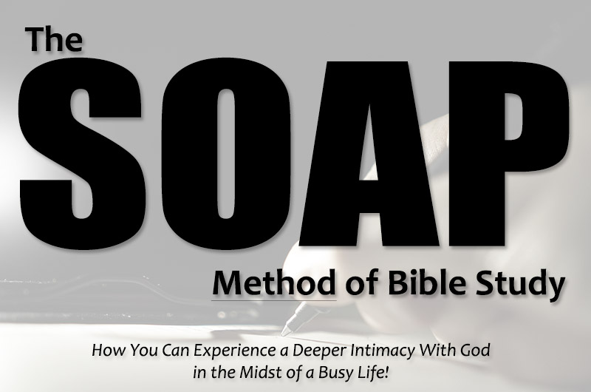

**What does SOAP stand for in Bible Study?**

**S – Scripture**

First, choose the passage of scripture for your study. As you meditate and allow the Holy Spirit to direct and guide you, choose one or a set of focus verse(s) that God uses to speak to your heart. Write out that verse in the scripture session.

**O – Observation/Overview**

This is where we dig a little deeper into scripture by using the who, what, when, where, and why. **Who** is writing, **when** was the writing done, **who the audience is**, **why** is the author writing them, and **what** are the instructions to them, i.e., identify what is going on in this passage.

Sidenote: Jot down any warnings are commands. Do any words stand out to you?

**A – Application**

Next, after examining the passage, apply the text to your own life. How do the verse or verses or passage you chose apply to your life? Ask yourself these questions:

* How can I live in light of what I’ve learned?
* How will I allow this scripture to change me?
* How do I need to repent?
* What false beliefs do I need to turn from?
* What truths do I need to believe?
* What can I do - empowered by the Holy Spirit - to apply this passage?
* How can I turn and obey and walk forward in the confidence of the gospel?
* How can I obey this with joy and not just begrudged obedience?
* Life Application #1:
* Life Application #2:

**P – Prayer Points**

In closing, pray God’s Word, your chosen verse, back to Him. Ask God to help you apply what you’ve learned to your life. Pray that He would open your eyes to opportunities to live out what you learned through your Bible study time.

Prayer Point #1:

Prayer Point #2:

**SOAP Bible Study Example**

**Passage of Scripture: Romans 12**

**Focus Verses: Romans 12:1-2**

**S – Scripture**

Do not conform to the pattern of this world, but be transformed by the renewing of your mind. Then you will be able to test and approve what God’s will is – his good, pleasing, and perfect will. Romans 12:1-2

**O – Observation/Overview**

**Who** is the penman of this passage, **where** were they when they wrote the passage, **who** is the audience, **why** is this audience receiving this letter, **when** was it written, etc.

Paul is writing to the Romans from Corinth in A.D. 56-57 telling them to offer themselves as living sacrifices. He also warns them not to conform to the pattern of this world and to be transformed by renewing their minds. He then encourages them that the result of these things is knowing/understanding God’s will.

**A – Application (How do we as disciples of Christ apply this scripture lesson to our lives in 2023 and beyond)**

Life Application #1: We need to be intentional and purposeful in renewing our minds by reading God’s Word. By doing so, we will better understand God’s will for our lives.

**P – Prayer Points (How do I implement this passage of scripture in my prayer life)**

Lord, create a hunger and desire in my innermost being to want to be in Your presence and your Word. Please help me to make this a part of my daily life, even when I don’t feel like it. Help me to choose time with You over sleeping in and scrolling my phone, ridding myself of distractions that take time from me being with You. Thank You for your faithfulness to me even when I am not always faithful to You.

